**Committee:** Food and Agriculture Organization of the United Nations (FAO)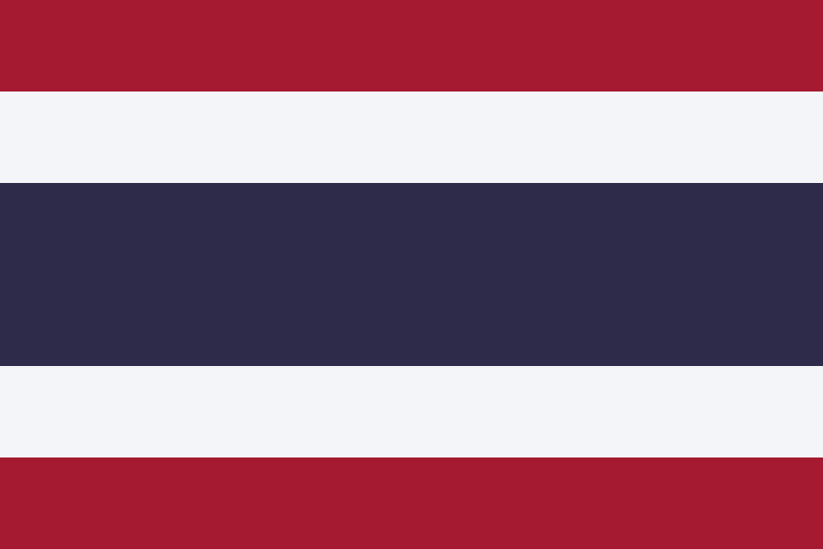

**Country:** Thailand

**Topic:** The Implementation of Sustainable Aquaculture

**School:** British International School of Houston

**Delegate:** Faizaan Syed

**Thailand’s Aquaculture and it’s Progress to Sustainablilty**

The Food and Agriculture Organization of the United Nations (FAO) was established in October 1945; their mandate,- to “achieve food security for all and make sure that people have regular access to enough high-quality food to lead active, healthy lives.” The FAO has achieved several landmarks, including establishing the Codex Alimentarius, eradicating Rinderpest, and focusing on aquaculture recently. The Global Seafood Alliance defines aquaculture as "the controlled cultivation of aquatic organisms for human consumption". Approximately 50% of all seafood originates from aquaculture, and that number is climbing; exemplifying the need for us to farm seafood, sustainably. However, the main challenge with aquaculture is the lack of space. Whether it's on the coast for land containers or in the ocean for marine containers, the growing need for aquaculture *needs* more space. In response, farmers are starting to convert mangroves and agriculture land to aquaculture land. Furthermore, endangered species across the oceans are starting to deplete, making it vital for everyone to begin establishing aquaculture in a sustainable fashion, as pursuing this cultivation strategy while considering other issues across the world (climate change, sea levels, etc..) will inspire action on a global scale.

Seafood is a major source of nutrition for Thais, thus illustrating how much seafood Thailand consumes. Approximately 28082.34 million US dollars’ worth of seafood is imported by Thailand, and Thailand is committed to sourcing all of it sustainably. Using shrimp farms as an example, Thailand works with the World Wildlife Fund (WWF) to make them more sustainable. According to the WWF, “Shrimp farming is associated with mangrove destruction, water pollution, and illegal fishing,” but compensations such as mangrove reforestations and community-wide cleanups makes those shrimp farms largely sustainable. Thailand’s fishery sector is categorized into two sections: capture fisheries (inland and marine) and aquaculture (coastal and freshwater). In 2019 alone, Thailand received 779,423 megatonnes of seafood from aquaculture fisheries, and 60,621 megatonnes from inland capture fisheries. A National Fisheries Committee was established pursuant to The Royal Ordinance on Fisheries (both bodies exist in Thailand), and said committee has the power and duty to develop fishery policies. Some implemented policies include the National Aquaculture Development Policies (NAqDP), a legislation that outlines aquaculture relative to other governmental initiatives such as economic and agricultural plans. The Royal Ordinance on Fisheries also produced a Fisheries Management Plan (FMP). The FMP has already made advancements regarding overfishing and overcapacity, along with illegal fishing. Making Thailand’s aquaculture industry is not easy, but it has progressed, yielding impressive results.

Thailand suggests educating the public about the Global Seafood Alliance (GSA) and Best Aquaculture Practices (BAP) and their advantages. GSA focuses on responsible seafood and aquaculture advancements globally, and BAP, a branch of GSA, is an aquaculture certification programme. In fact, both Salim Pasha and Basheer Ahmed of Aquasource Inc., - an aquaculture importing company- say that “BAP is the certification we look for when buying seafood.” From farm to processor, BAP certifies every aspect of the seafood supply chain. Many people have never heard of these organizations, let alone the term aquaculture; for this reason, the delegation of Thailand believes that educating the consumer regarding aquaculture-related corporations, and raising awareness will help increase understanding regarding the benefits of implementing sustainable aquaculture. Moreover, Thailand feels more organizations should partner with local aquaculture farms to make sustainable aquaculture more popular and common to scale it up. Lastly, companies like Aquasource Inc. should encourage institutions like BAP and GSA so suppliers are sustainable globally. These resolutions will revolutionize the implementation of sustainable aquaculture, positively.

**Work Cited**

Racine, Phoebe. “Making Shrimp Sustainable in Thailand.” *WWF Seafood Sustainability*, 19 July 2022, https://seafoodsustainability.org/making-shrimp-sustainable-thailand/. Accessed 28 November 2022.

*Translation Royal Ordinance on Fisheries B.E. 2558 (2015) Bhumibol Adulyadej, Rex BHUMIBOL ADULYADEJ, REX; Given on the 13th Da*, https://www.fisheries.go.th/law/web2/images/PR2558/6-royalfisheries.pdf. Accessed 28 November 2022.

“About FAO.” *Food and Agriculture Organization of the United Nations*, https://www.fao.org/about/en/. Accessed 28 November 2022.

“Fisheries Country Profile: Thailand (2022) – SEAFDEC.” *SEAFDEC*, http://www.seafdec.org/fisheries-country-profile-thailand-2022/. Accessed 28 November 2022.

“What is Aquaculture, and Why Do We Need It?” *Global Seafood Alliance*, 27 March 2019, https://www.globalseafood.org/blog/what-is-aquaculture-why-do-we-need-it/. Accessed 28 November 2022.

“Aquaculture - Fishery and Aquaculture Country Profiles.” *Fisheries and Aquaculture - Fishery and Aquaculture Country Profiles*, https://www.fao.org/fishery/en/facp/THA. Accessed 28 November 2022.

“What is aquaculture?” *National Ocean Service*, 26 February 2021, https://oceanservice.noaa.gov/facts/aquaculture.html. Accessed 28 November 2022.

“Fisheries and Aquaculture - National Aquaculture Legislation Overview - Thailand.” *Food and Agriculture Organization of the United Nations*, https://www.fao.org/fishery/en/legalframework/th/en?lang=en. Accessed 28 November 2022.